Recap séquence PINK & BLUE

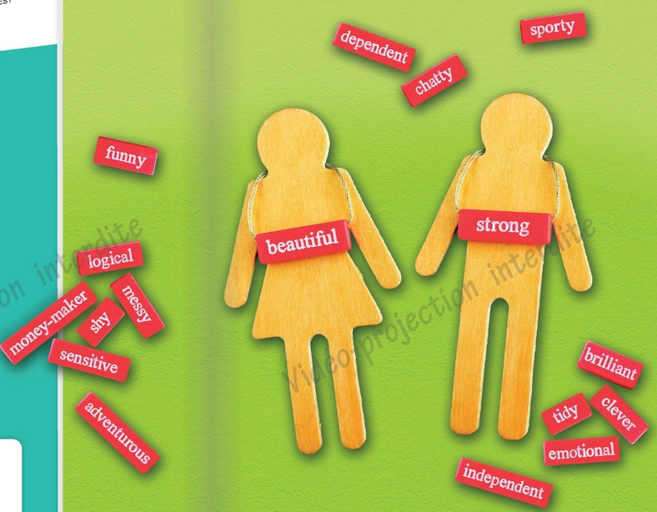

As we have studied today, some labels tend to be associated with men or women. For instance, a woman is supposed to be chatty and emotional, whereas a man is going to be rather clever and adventurous. These are called gender stereotypes. They are mainly spread by what we call role models. A vast majority of students is aware that gender stereotypes are an issue today. How can we fight against them?
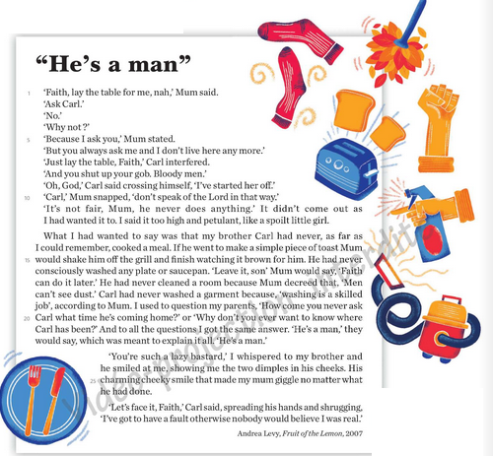

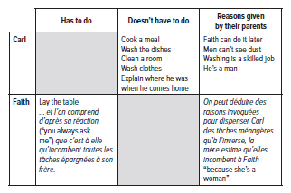

- He’s a man”. What do the parents mean by that?

Men are not supposed to do the housework. They are genetically unfit to do the housework. Men are not meticulous enough to do it as it should be done. They have more important things to do than the housework. Doing the housework is a skill passed on from mother to daughter.



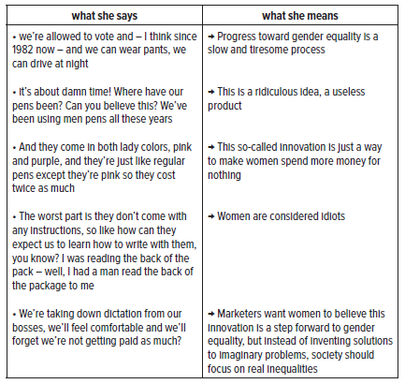

Ellen uses irony and satire throughout her monologue; she acts as if we were in the 1920s. She then says that women are incapable of thinking for themselves.

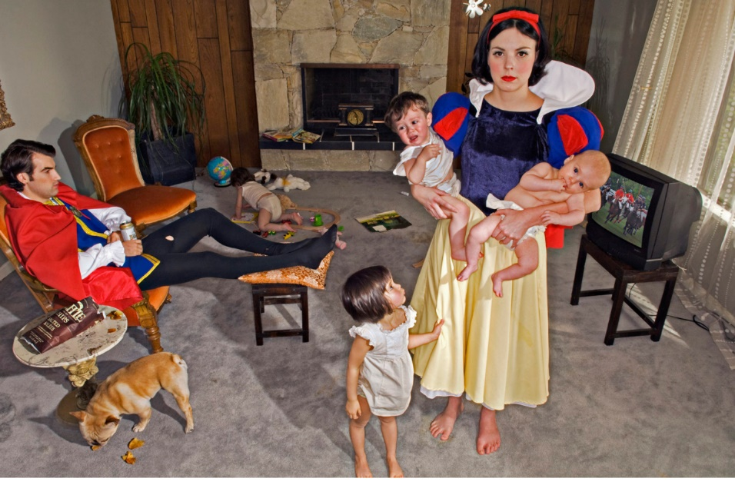

- Snow White is holding two of her children. One of them is crying, another daughter is pulling on her skirt, while a fourth one is crawling in a corner of the room.

- A dog is sniffing the carpet.

- Snow White is staring at us while her husband id relaxing and watching a sporting event on TV. He is holding a can of beer.

- The scene takes place a few years after Snow White’s wedding to the Prince

- They are supposed to live happily ever after, but obviously it is not the case. There seems to be no communication or love between them. They seem totally estranged from one another.

